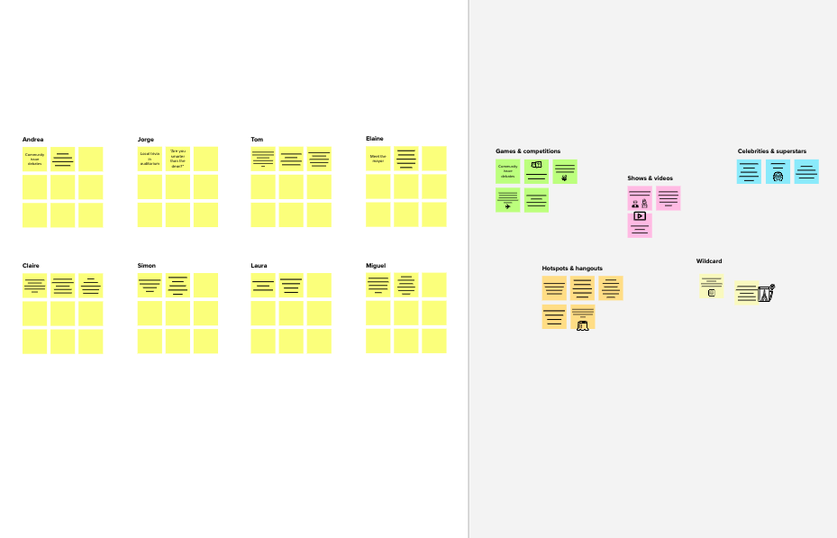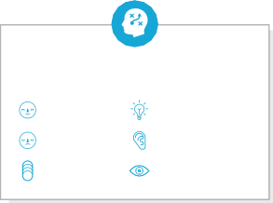

# Brainstorm

**TIP**

You can select a sticky note and hit the pencil [switch to sketch] icon to start drawing!

## Before you collaborate

### A little bit of preparation goes a long way with this session. Here’s what you need to do to get going.

#### 10 minutes

**1**

## Define your problem statement

### What problem are you trying to solve? Frame your problem as a How Might We statement. This will be the focus of your brainstorm.

#### 5 minutes

**2**

## Brainstorm

### Write down any ideas that come to mind that address your problem statement.

#### 10 minutes

**3**

## Group ideas

### Take turns sharing your ideas while clustering similar or related notes as you go. In the last 10 minutes, give each cluster a sentence-like label. If a cluster is bigger than six sticky notes, try and see if you and break it up into smaller sub-groups.

#### 20 minutes

**4**

## Prioritize

### Your team should all be on the same page about what's important moving forward. Place your ideas on this grid to determine which ideas are important and which are feasible.

#### 20 minutes

**After you collaborate**

You can export the mural as an image or pdf to share with members of your company who might find it helpful.

**Quick add-ons**

**TIP**

Add customizable tags to sticky notes to make it easier to find, browse, organize, and categorize important ideas as themes within your mural.

Go through dataset carefully

Understand the data

**& idea prioritization**

**Choosing the selective metrics present in our dataset to attain success**

**PROBLEM**

How might we perform Sales Analytics during this Pandemic ?

##### Team gathering

**M.Nithish kumar**

Lead Generation

**M.Parthiban.**

**K.Perumalsamy**

Search for Cold leads

**R.Pragatheesh.**

Use this template in your own brainstorming sessions so your team can unleash their imagination and start shaping concepts even if you're not sitting in the same room.

Define who should participate in the session and send an invite. Share relevant information or pre-work ahead.

##### Set the goal

Think about the problem you'll be focusing on solving in the brainstorming session.

##### Learn how to use the facilitation tools

Use the Facilitation Superpowers to run a happy and

Choose the right datati

Selection of required metrics in the dataset

Have a relationship with Customer through Marketing Campaigns

Simple analytics tool

Find the perfect analytics tool

Find the useful Data

Understandable templates

Using Sales Forecast

CRM

platform for data storage

Identify bottlenecks

Let the Dashboard be narrative

Let it be simple

Opt for right analytics tool

Don't use more colors in chart

Build relationship with past customer

Select the right type of chart

##### Share the mural

**Share a view link** to the mural with stakeholders to keep them in the loop about the outcomes of the session.

##### Export the mural

Export a copy of the mural as a PNG or PDF to attach to emails, include in slides, or save in your drive.

**10 minutes** to prepare

**1 hour** to collaborate

**2-8 people** recommended

productive session.

##### [Open article](https://support.mural.co/en/articles/2113740-facilitation-superpowers)

**Key rules of brainstorming**

To run an smooth and productive session

## Keep moving forward

##### Strategy blueprint

Define the components of a new idea or strategy.

##### [Open the template](https://app.mural.co/template/e95f612a-f72a-4772-bc48-545aaa04e0c9/984865a6-0a96-4472-a48d-47639307b3ca)

**Customer experience journey map**

Stay in topic. Defer judgment.

**Use eye appealing and narrative dashboards**

Encourage wild ideas. Listen to others.

## Importance

If each of these

**TIP**

Participants can use their cursors to point at where sticky notes should go on the grid. The facilitator can confirm the spot by using the laser pointer holding the **H key** on the keyboard.

Understand customer needs, motivations, and obstacles for an experience.

##### [Open the template](https://app.mural.co/template/b7114010-3a67-4d63-a51d-6f2cedc9633f/c1b465ab-57af-4624-8faf-ebb312edc0eb)

**Selection of Right Sales Analytics Tool**

Go for volume. If possible, be visual.

tasks could get

done without any difficulty or cost, which would have the most positive impact?

##### Strengths, weaknesses, opportunities & threats

Identify strengths, weaknesses, opportunities, and threats (SWOT) to develop a plan.

|  |  |
| --- | --- |
|  |  |
|  |  |

##### [Open the template](https://app.mural.co/template/6a062671-89ee-4b76-9409-2603d8b098be/ca270343-1d54-4952-9d8c-fbc303ffd0f2)

[**Share template feedback**](https://muralco.typeform.com/to/CiqaHVat?typeform-source=app.mural.co)

[**Share template feedback**](https://muralco.typeform.com/to/CiqaHVat?typeform-source=app.mural.co)

**Feasibility**

Regardless of their importance, which tasks are more feasible than others? (Cost, time, effort, complexity, etc.)

**Template**

**Need some inspiration?**

See a finished version of this template to kickstart your work.

[**Open example**](https://app.mural.co/template/e5a93b7b-49f2-48c9-afd7-a635d860eba6/93f1b98d-b2d2-4695-8e85-7e9c0d2fd9b9)